Solve the programing exercise: Sum Rows of a Two-Dimensional Array

Read the following data in from a data file into a 2-dimensional array of 4 rows and 5 columns:

22 33 44 55 66 77 88 99 12 21 32 41 53 46 76 89 90 67 93 20

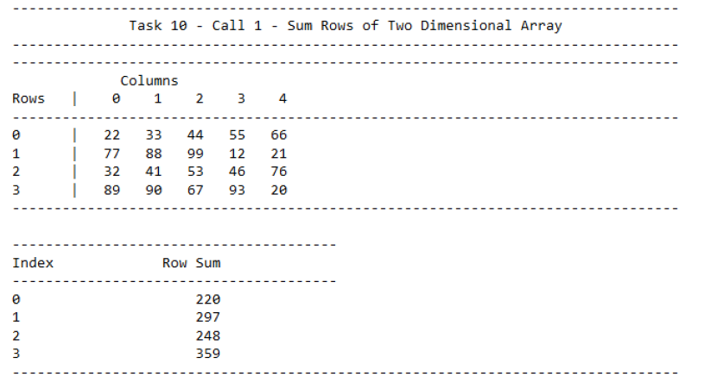

In the Main:

// Task 10 - One and two dimensional arrays used to sum integer values

int oneDimensionalTask10[TWO_DIMENSIONAL_ARRAY_ROWS] = { 0 };

int twoDimensionalTask10[TWO_DIMENSIONAL_ARRAY_ROWS][TWO_DIMENSIONAL_ARRAY_COLUMNS];

void SumTwoDimensionalArray(int array[MAX_2D_ARRAY_ROWS][MAX_2D_ARRAY_COLUMNS], int sumArray[MAX_2D_ARRAY_ROWS], int row, int column)

{

//If all at the final element in the 2-dimensional array

if (column == (MAX_2D_ARRAY_COLUMNS-1) && row == (MAX_2D_ARRAY_ROWS - 1))

{

sumArray[row] += array[row][column];

}

else

{

//Increment the sum array

sumArray[row] += array[row][column];

//change to the next row if at the end of the row

if (column == (MAX_2D_ARRAY_COLUMNS - 1))

{

column = 0;

row++;

}

else

{

column++;

}

//Call the function again with the changes to row and column

SumTwoDimensionalArray(array, sumArray, row, column);

}

}